Step 1. Connect SSH into the ec2 instance through SSH using Putty

Step 2. Running the file in AWS

Step a: Connecting to AWS Instance using PUTTY

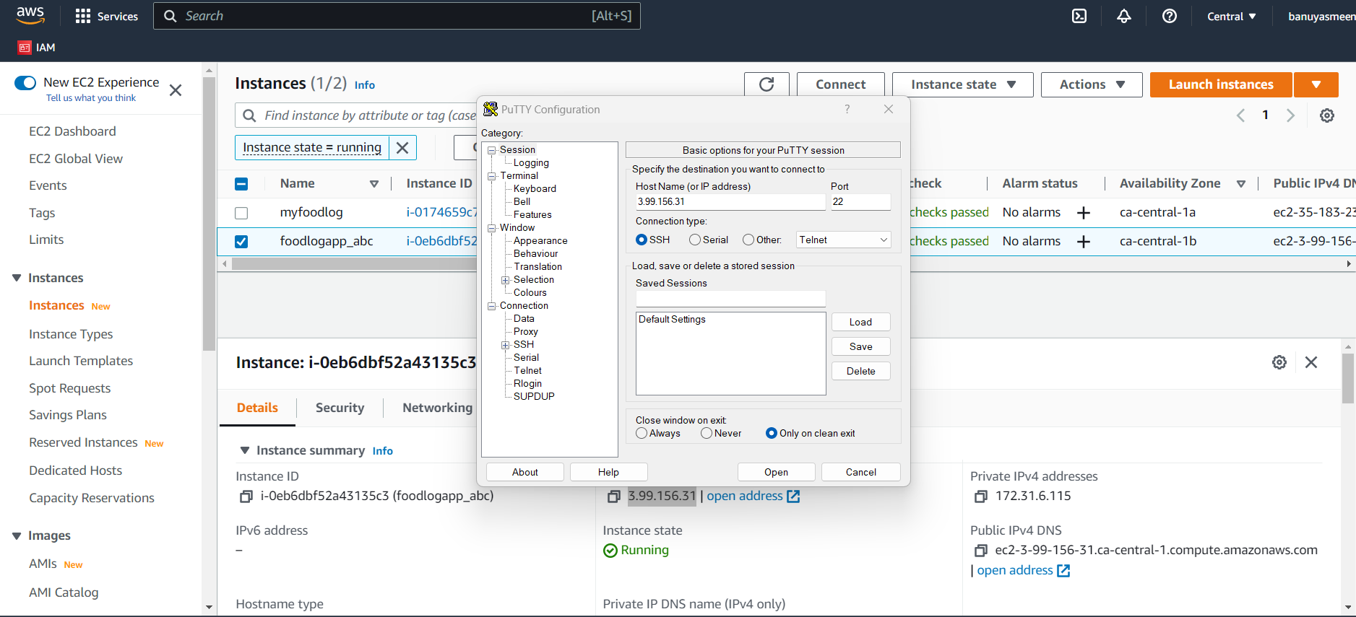

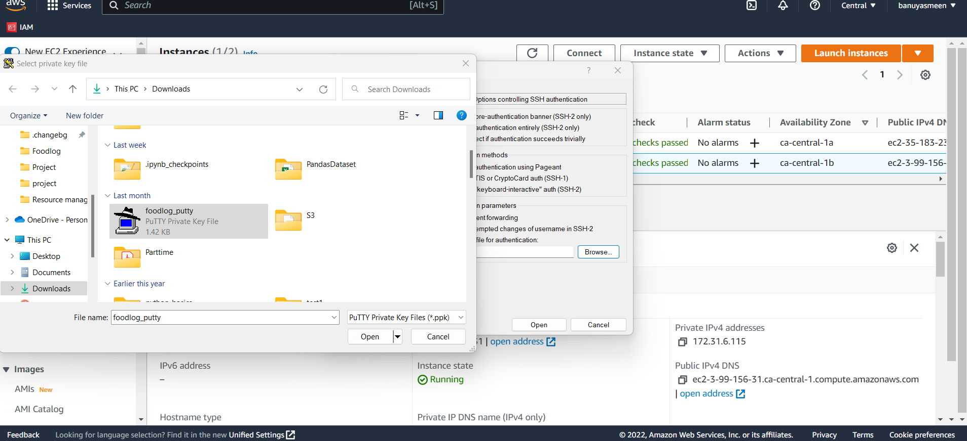

Step b: sudo su - this will change the directory to root

Step C: yum update -y - this will update the EC2 instance

Step d: yum install httpd -y - this will install Apache

Step e: cd/var/www/html - this is to access EC2 instance

Step f: wget <<object URL>> - copy the zip file in the S3 bucket to EC2 Instance

Step g: unzip <<filename.zip>> - to unzip the file into Ec2 instance

Step h: unzip <<filename.zip>> - to unzip the file into Ec2 instance

Step i: mv <<foldername>>/* . - to move all the files into EC2 Instance from the folder within the zipfile .

Step j: service httpd start - this will start the server

SCREEN SHOTS OF THE APPLICATION

